**Team Leader :** Prabha M

**Name:** Saranya A

**Assignment:** Build a python code. Assume u get temperature and humidity values and write a condition to continuously detect alarm in case of high temperature

**Date:**25-09-2022

**CODE:** import random while(True):

temp=random.randint(10,99) humid=random.randint(10,99)

print("current temperature:",temp) print("current humidity:",humid,"%") temp_ref=37 humid_ref=35 if temp>temp_ref and humid<humid_ref:

print("Sound Alarm") else:

print("Sound off") break

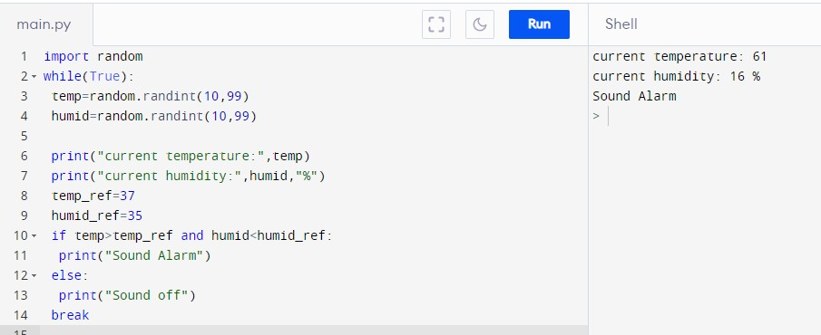

**Output :**